Tape vs Disk vs Cloud: A comparison of Data Backup Options
Blog Business Continuity & Disaster Recovery Tape vs Disk vs Cloud: A comparison of Data Backup Options
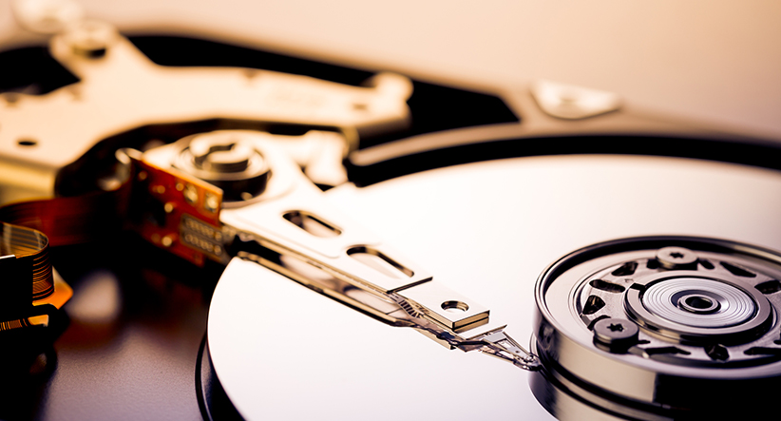
November 20, 2017 / Evolve IP
Business continuity plans are a must in today’s environment, where even a few hours of downtime could be very costly in lost revenue. Data backup procedures are a critical part of these business continuity plans. But as the menu of backup options increases with the introduction of new technologies it can be difficult to pick criteria around which to base your data backup decisions.
Whether you are looking to replace aging infrastructure, have suffered from faulty or incomplete backups, or are just planning for the future, here is a comparison of the three most common options—tape, disk and cloud backup—along with criteria of price, labor, efficiency, and longevity.
Tape-based backup
Tape was the primary method for data backup beginning in the 1960s and 1970s. Since it has been around so long, it has evolved and grown with businesses for more than four decades. A decision to go with (or stick with) tape-based backup, therefore, means few, if any, infrastructure improvements are necessary assuming your company has previously used this method.
A lack of infrastructure improvements is one area from which cost savings are derived. The other is the cost of the tapes themselves. Tapes are generally a cheap alternative to other storage methods, though this also depends on the amount and type of data your organization will regularly need to back up.
Tapes also enable the opportunity for multi-site data storage. As with any business continuity plan, it is a good idea to ensure multi-site data redundancy so that a catastrophe in one location does not run the risk of wiping out mission-critical data. However, this method of multi-site tape storage can be inefficient and costly once you factor in expenditures for secure tape transit and storage in data centers or other external facilities.
Tapes also suffer from some of the expected shortcomings of older technologies. Reading from and writing to tapes takes longer than other backup methods. There is a higher chance of data corruption or problems reading data from tapes than, say, disk-based backup. Further, data restoration from tapes needs to be completed in the correct sequence, just as if you were going through playlists in a certain sequence on an audio tape. Needless to say, that sequence necessity can complicate backup and restoration processes.
Though tapes have indeed been around the longest, they are also subject to change. Backup tapes come in many shapes and sizes—literally—so you may also encounter some unforeseen infrastructure costs to support the physical media.
Disk-based backup
Generally speaking, disk-based backup is significantly quicker and more reliable for data restoration than tape-based backup. Instead of writing from disk (such as your hard drives or servers) to a tape, a disk-to-disk backup is simply a more efficient method of data transfer.
Similarly, restoration from disk is a relatively efficient process. You’ll avoid the hassles of retrieving, sequencing and then replicating tapes one by one. Disk-based backup is thus a quicker restoration method.
Perhaps the biggest drawback is that disk-based backups still reside in your on-site data location. For multi-location data redundancy, you would need to use a third-party provider for off-site backup, or a replication of the on-site disk. If you opt to circumvent the need for an off-site provider, it can become expensive to continue buying disk space, not to mention the extra process of doing it yourself.
Of course, you could also take your disk replicas and back them up to tape. This is a hybrid of a tape and disk-based backup and is an alternative to paying high prices for disk space. Those costs could still add up, though, in the extra labor and infrastructure costs associated with maintaining the tape-based backup along with disks.
Cloud-based (online) backup
Cloud-based or online backup refers to off-site backup to a third party service provider (or your own cloud infrastructure) via cloud enablement technologies and/or on-site appliances.
Per gig, you can generally store data with greater cost efficiency in a cloud, which eliminates the need to buy and refresh tapes or disks. Online backup is also a less labor-intensive process, as replication is handled as a managed service. This eliminates the need to spend hours each week physically managing backups or securing and transporting tapes.
Cloud-based backup inherently includes multi-site data redundancy, as well. A local data copy can live in an on-site appliance like the SmartFrame, while that enablement technology also replicates data to your off-site provider or data center. Such appliances and enablement technologies continually run in the background of your IT operations, eliminating some of the headaches of manual IT processes. Administrators can also provision VMs on such appliances, simultaneously using the appliance to back up the VMs off-site.
Of course, you’ll need the appropriate bandwidth to support the off-site replication of changes in your data. Depending on your current capabilities, it may mean you need to replicate less data or, more realistically, spend money on network optimization. Additionally, there will be some time and effort as you transition to a new cloud deployment, though this will vary depending on the amount of data you’re looking to transition to the cloud. Online backup is, then, a flexible backup option since you may choose to move only some of your more critical data to the cloud.
Since it is a newer technology, some perceived security concerns linger around the cloud. Many wonder whether off-site data backup will open their data streams to breaches from a third party or some unintended mingling of data with other customers residing in a given data center. However, newer cloud infrastructures are built securely and can actually avoid many of the potential pitfalls associated with, for example, transporting and storing tapes or disks in colocation facilities.
How to make your decision
Every backup model will have its benefits and drawbacks—it is indicative of the imperfect nature of technology that we are continually making progress in speed, efficiency and security. As you make decisions regarding your company’s backup methods, take a close look at:
- The amount of data that is regularly updated in your organization
- Your current bandwidth capabilities
- Your current backup-related costs and overall IT budget
- Hardware considerations, including your current infrastructure and any necessary upgrades
- The number of locations from which you’ll need to back up and transport any backup tools
- Your long-term IT strategy and the potential longevity of various backup methods
- Your internal resources, both in terms of time and labor, and if those resources are sufficient to manage do-it-yourself projects or would benefit from managed services
You should also consider timing. If your infrastructure is in good shape and your backup processes are sustainable, you can probably hold off on pursuing immediate changes to your backup architecture. But if your company is looking at a necessary update to back up infrastructure, a transfer of data centers, or general company expansions or acquisitions, it will be worthwhile to reconsider your business continuity plans and how each backup option might serve your organization’s future needs.

